User manual
8th August 2024

Overview
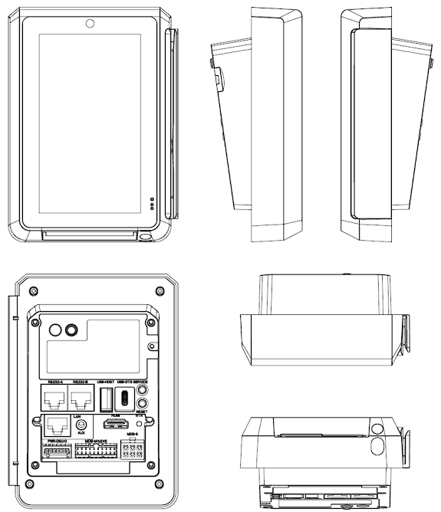
Figure 1: view from all sides

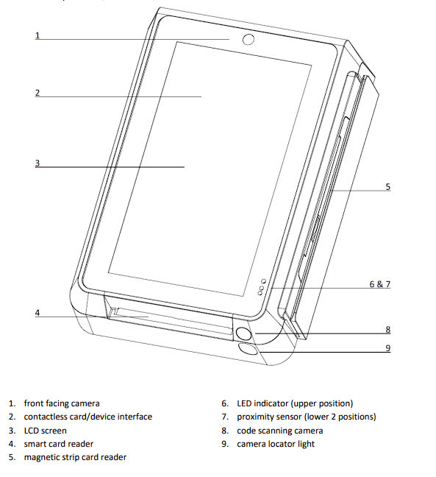
Figure 2: components and interface (front)

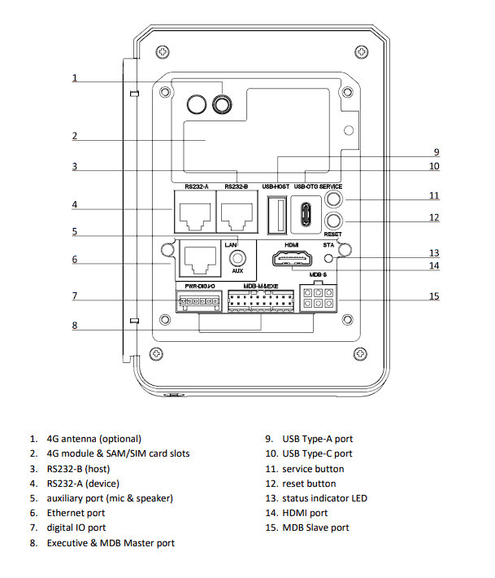
Figure 3: components, interface and ports (back)

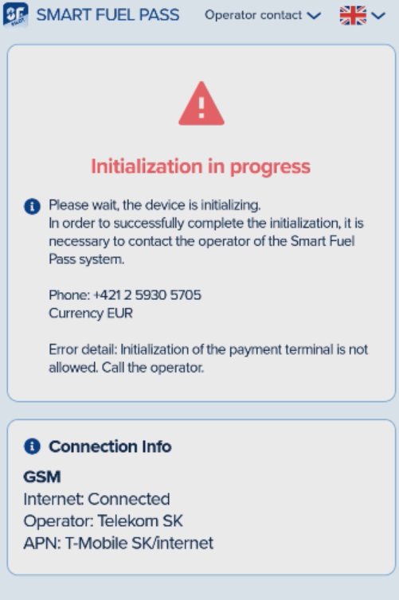  Figure 4: initialization of the device | First start  When you start your OPT for the first time and run the OP-UPT, you will be welcomed with this screen, provided the terminal is connected to the internet and no error has occurred.  Please go ahead, and call the number displayed. This step is necessary in order to initialize the device.

1.1 No internet connection  If the terminal displays this error after starting, it means that internet connection has not been set up properly. | 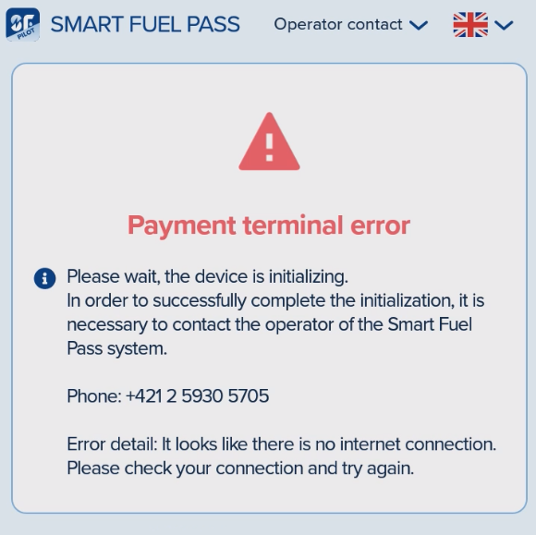  Figure 5: no internet connection

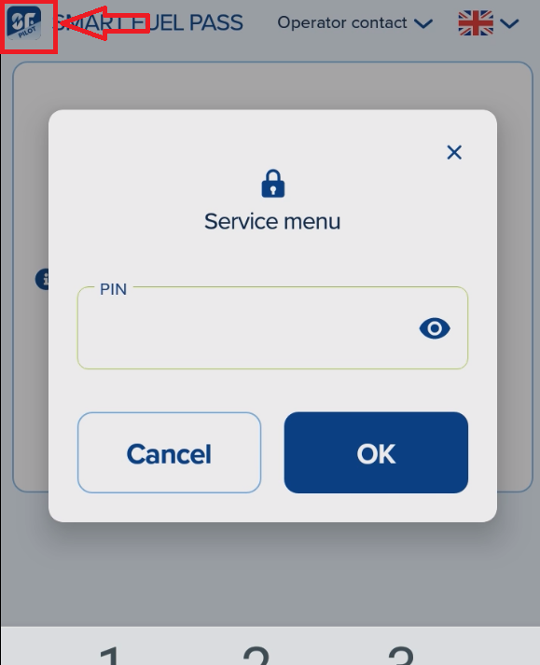  Figure 6: enter PIN code | Tap and hold the blue icon in upper left corner for about 2 seconds to enter the Service menu. You will be asked to enter the PIN code of your terminal. If you don’t know your PIN yet, please log in your account at https://portal.smartfuelpass.com and switch to the Point of Sale manager role. Open the Payment terminals tab and the PIN will be displayed next to your terminal. If your terminal is not displayed in this section, please call our support to add it to your point of sale.

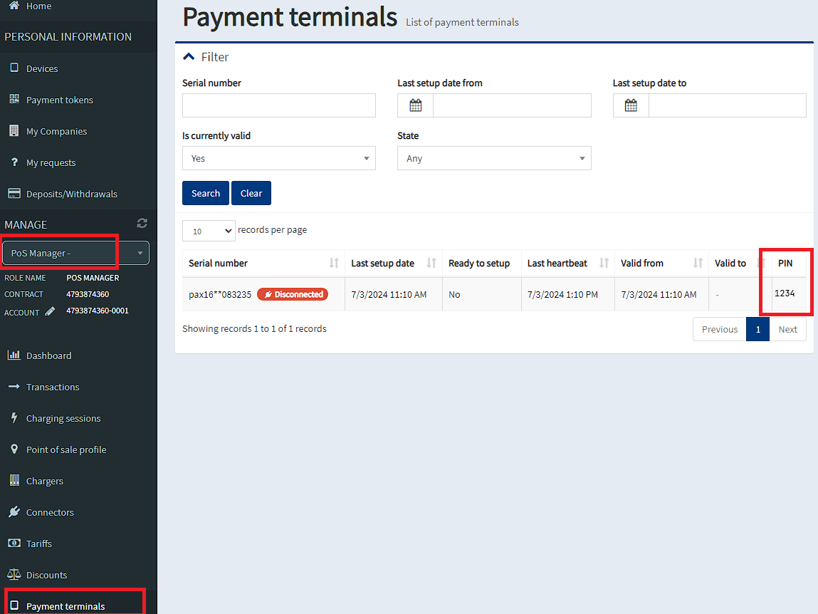
Figure 7: location of PIN code

After opening the service menu, please scroll down to reveal the options for setting up the internet connection. If you wish to set up multiple connections as a backup, please note that the connection priority is Ethernet -> Wi-Fi -> GSM.
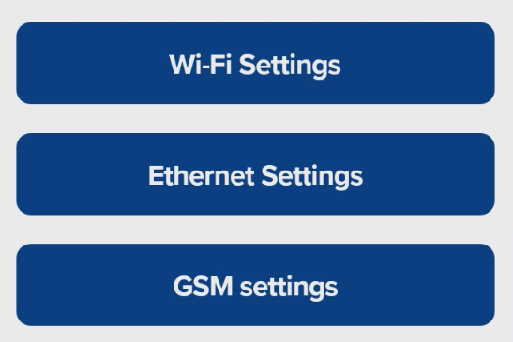
Figure 8: internet connection options
- If you plan to use Wi-Fi, please go to Wi-fi Settings and configure your connection. Since the PAX IM30 is based on Android, setting up Wi-Fi connection is similar to most Android phones.
- If you plan to use an ethernet connection, go to Ethernet Settings. In this menu you can set up all required parameters. Default setting is DHCP, but it is possible to configure a static IP address as well.
- In GSM Settings you can configure a GSM connection. Please note that the SIM card must have an unlocked PIN code. After inserting the card, all settings should be configured automatically. If you need help with inserting the card, you can follow instructions in this video: Video manual

1.2 Errors

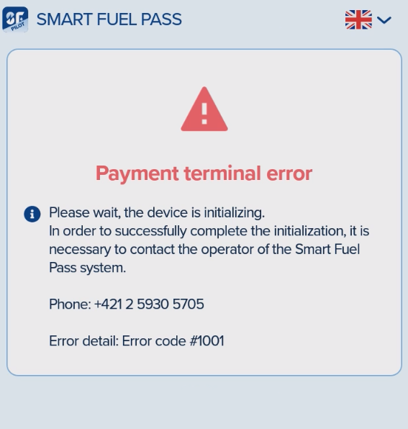
Figure 9: an error message
In some cases, it is possible that an error will be displayed, as seen in the screenshot above. Here is a list of errors and their descriptions
Code | Error
#1001 | Payment application not installed - remote service required
#1002-#1012 | Payment application not configured correctly - remote service required
If any of these error messages are displayed after the terminal has been connected to the internet, please call the displayed number.

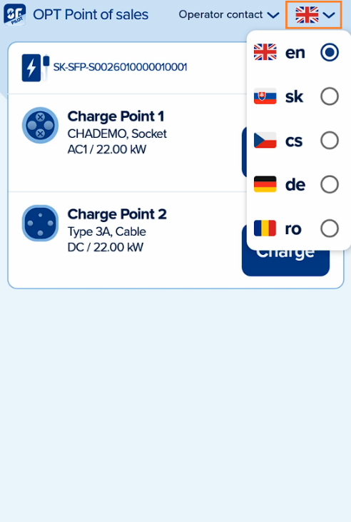  Figure 10: language settings | First look  Language of the app can be changed by tapping the flag icon located in upper right corner

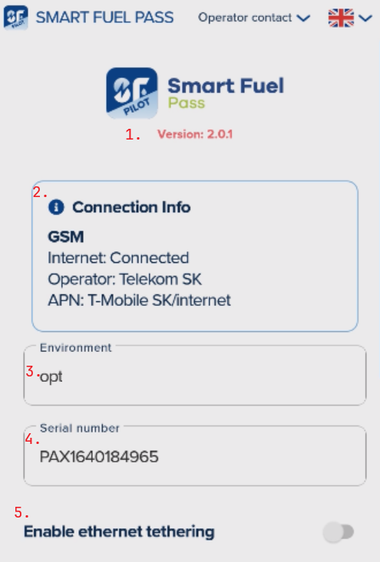
Figure 11: first part of the Service menu
- Installed version of the application
- Connection info displays information about currently used internet connection
- Environment is used mostly for development and testing purposes, this information can be ignored and should not be changed by the operator in most cases
- The serial number displays the serial number of this terminal. This information might be required during the setup of OPT on a point of sale
- Enables or disables ethernet tethering

Service menu  The service menu is only accessible to OPT operators, clients are unable to access it. This section of the manual explains each sub-section and its functionalities.  To access the Service menu, tap and hold the icon located in upper left corner of the screen for 2 seconds. You will be asked to enter the PIN code.  This menu contains various app and connection settings. | 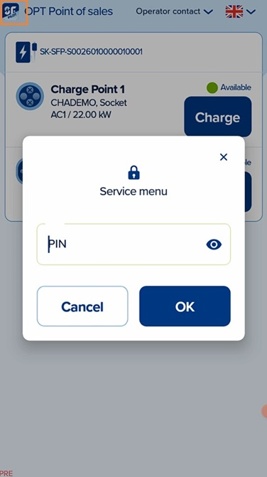  Figure 12: service menu
Scrolling down reveals more options:
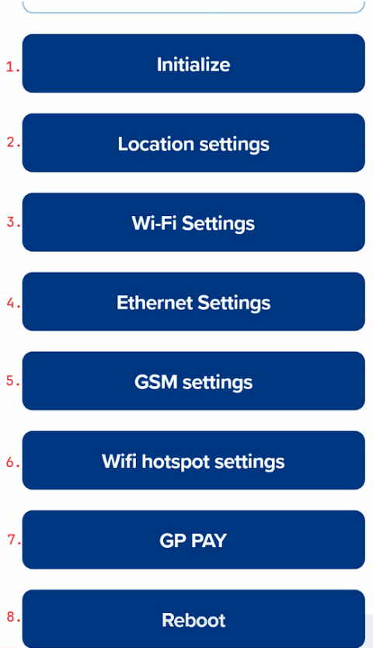
Figure 13: service menu options

- Initializes the device. Used during initial setup of the OPT on a point of sale.
- Location settings allow you to display or hide connectors of all charging stations in your point of sale
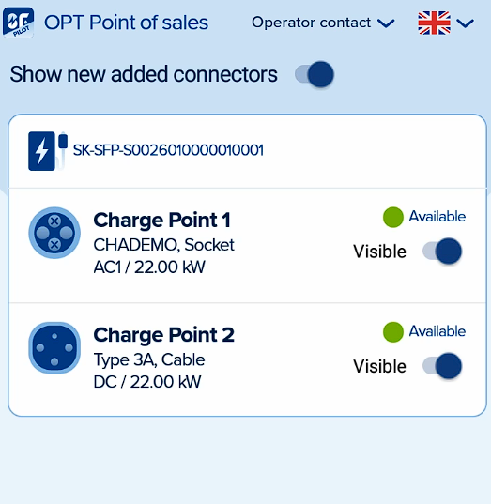  Figure 14: location settings | If the “Show new added connectors” option is turned on, after a new charger is connected to this point of sale, its connectors will show up on the terminal. If the option is turned off, new connectors will not be displayed after adding a new charger.  Since each point of sale might have multiple chargers, connectors and OPTs, by switching “Visible” next to a connector to “off,” you can hide connectors that are not relevant to this terminal. If your point of sale has multiple connectors operated by a single terminal, all connectors can be left as Visible.

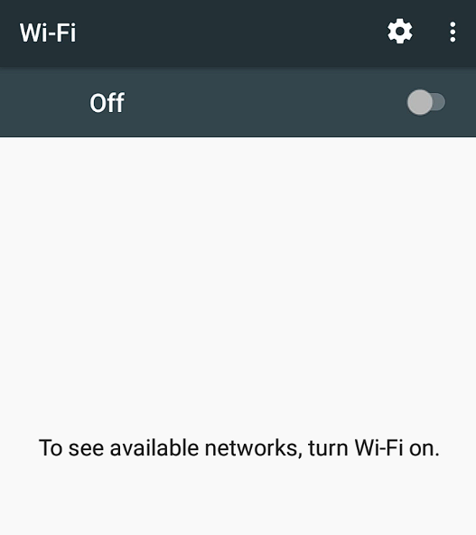  Figure 15: Wi-Fi settings | - If your OPT is connected via Wi-Fi, connection can be set up in this menu

- Ethernet connection can be set up in this menu | 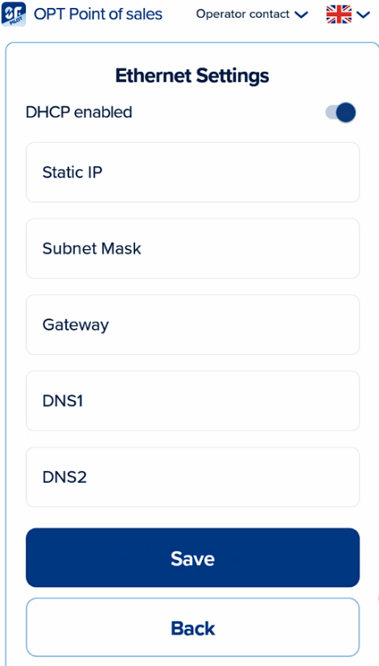  Figure 16: ethernet settings

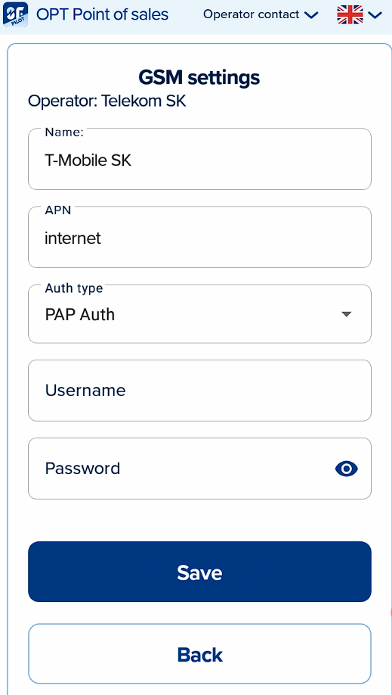  Figure 17: GSM settings | - This section contains GMS settings if your OPT uses a SIM card for internet connection

- If supported by the model of your OPT device, it can be turned into a Wi-Fi hotspot in this menu
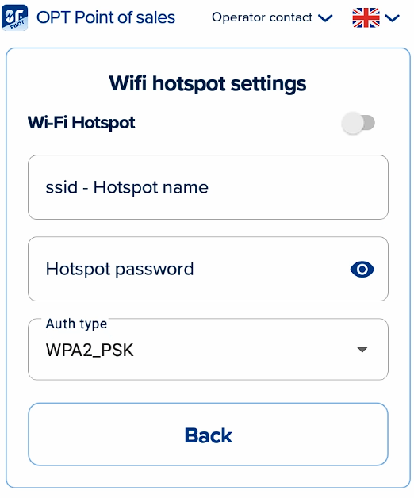
Figure 18: Wi-Fi hotspot settings
- GP PAY
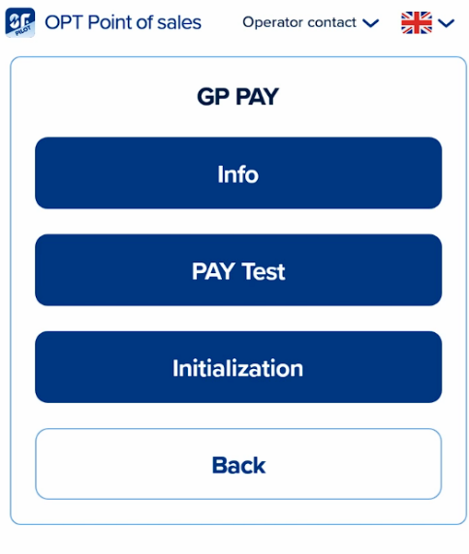
Figure 19: GP Pay options

- Reboots the device
- Tap the “Back to main” button to exit Service menu
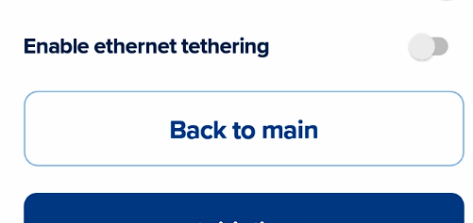
Figure 20: back to main menu button

EV-Charging
This section contains a step-by-step guide to charging EV’s via Smart Fuel Pass OPT solution.
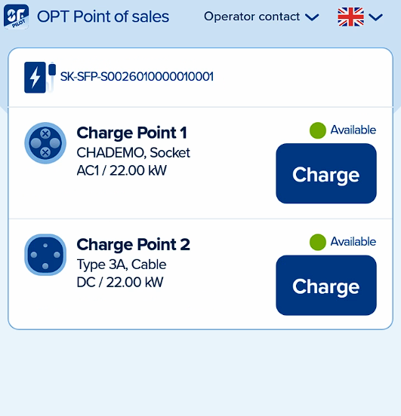  Figure 21: available connectors | This is the default screen of your OPT device. In the upper left corner, the name of your location or point of sale is displayed (in this case “OPT Point of sale”).

Tapping the “Operator contact” button will display contact information such as address, phone number and e-mail, which can be customized in the Point of sale profile in your Smart Fuel Pass account. | 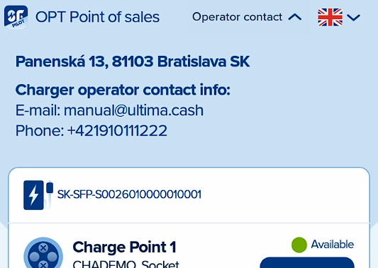  Figure 22: operator contact info displayed
All connectors with allowed “Visibility” are displayed under EVSE-ID of their charger, along with information about their standard, format, power type and power, as well as status. Depending on your setup, a single connector, or multiple chargers with their connectors will be displayed here.
- After selecting a connector, customer can view the tariff and select a payment method | 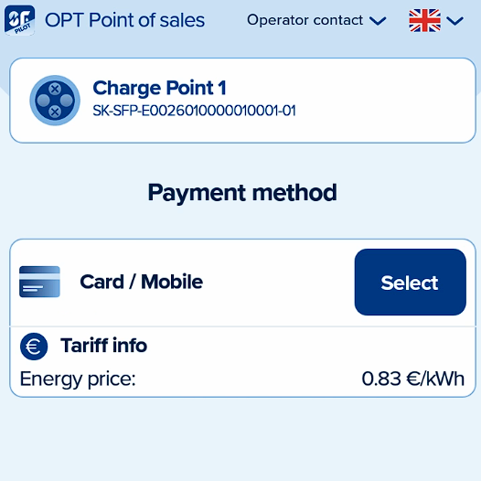  Figure 23: selecting a payment method
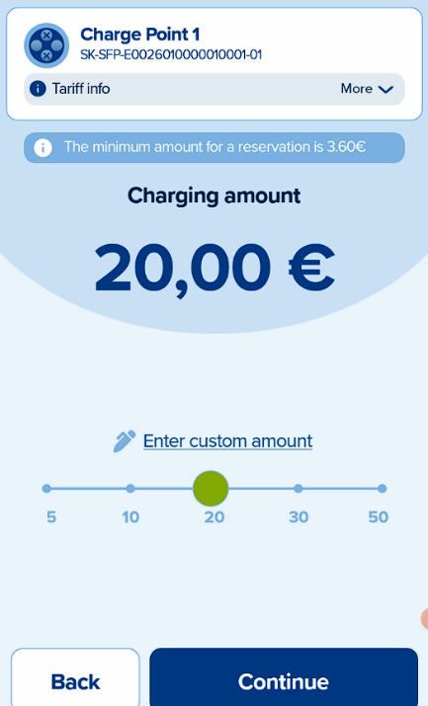  Figure 24: selecting charging amount | - On the following screen the customer is prompted to enter the charging amount either by using the slider or entering custom amount. Tariff info can be reviewed on this screen as well

- After submitting the desired amount, the customer will be prompted to provide a card or an NFC mobile device
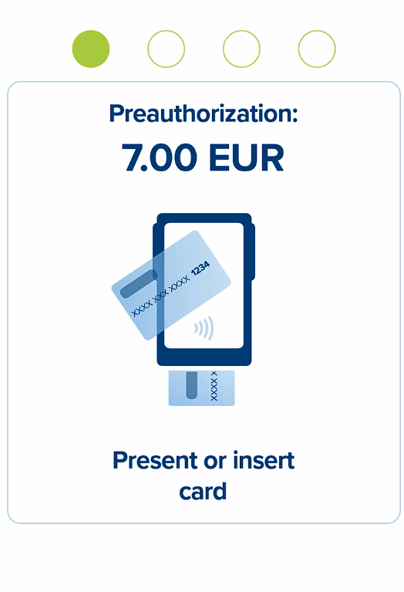
Figure 25: preauthorization screen

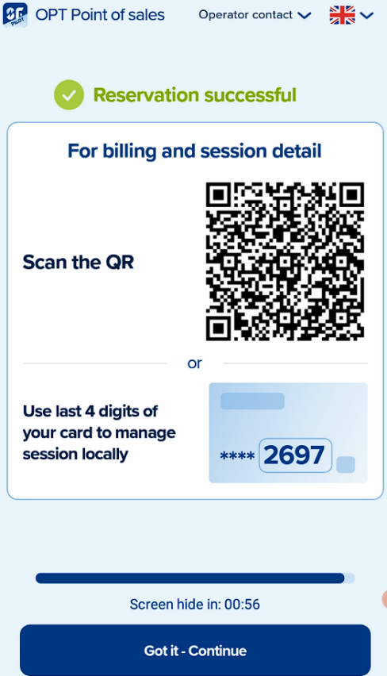  Figure 27: QR code for accessing the charging session | - If the authorization process was successful, charging will begin. This screen provides the customer with information about access to their charging session.
- The session can be viewed and managed remotely via phone by scanning the QR code, and/or directly on the terminal by providing the PAN code (last four digits of the payment card used in previous step)

